Design a Logo Contest for the Michigan Council for History Education

Are you creative? Do you have a great idea to go along with the theme? In cooperation with Wayne RESA, the Council is asking YOU for your ideas and designs. You have the chance to be named the Official Logo Designer for Michigan Council for History Education.
The MCHE is seeking an official logo to use as part of its activities. Entries are sought from 7th through 12th grade students. The Winning Entry will become the Official Logo of the MCHE.

Who is eligible: Any 7th-12th grade student enrolled in public or private school or home school program in the State of Michigan. A maximum of two entries will be accepted from each entrant.
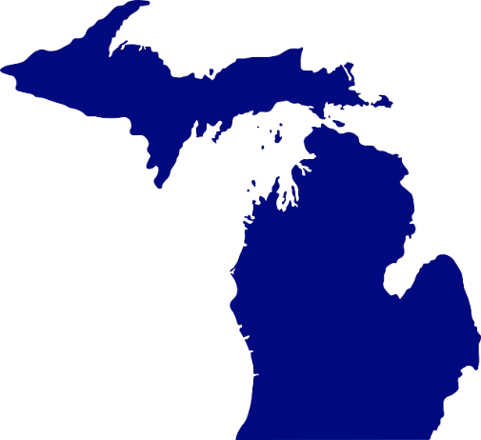
Design Guidelines:
1. Logo must include the words or symbols for: “Michigan”, “Council”,
“History”, and “Education”.
2. Logo must be easily reproducible in both color and black/white.
3. Logo must be simple enough to be reproduced clearly in small size, as a lapel pin.
4. Graphics should meet the Guidelines.

Contest Guidelines:
1. All artwork is to be original and done in both black /white and color.
2. Entries must be submitted on 8 1/2” x 11" sheet of white paper.
3. The contestant’s name, age, address, and phone number must be printed on the back of the entry. The
contest entry form must be included with the art work.
4. Entries must be submitted by Saturday, December 7, 2019, to:
David Hales, Social Studies Consultant,
Wayne County Regional Educational Service Agency, 33500 Van Born Road, Box 807 Wayne, MI
48184-2497 Office: 734-334-1311 Fax: 734-334-1478 E-mail: halesd@resa.net
5. The selected design or image may be reworked to prepare it for use.
6. The MCHE is not obligated to select any entry as the logo.

Contest Prizes:
1. All participants will be notified of selections no later than Monday, Jan. 20, 2020.
2. In addition to selection as the official logo, first place will receive a $200 award.
3. Up to three entrants will be selected for $50 Honorable Mention Awards.
4. The logo winner, finalists, and teachers will be contacted by January 20, 2020.

For more information about the MCHE Logo Contest, contact David Hales, Wayne RESA Social studies Consultant, at halesd@resa.net
_________________________________________________________________________________

Design a Logo Contest for the Michigan Council for History Education

Student Entry Form

Prize: $200
Deadline for Application: Saturday, December 7, 2019.
Notification of Selection no later than Monday, January 18, 2020.

Name: _____________________________________________________ Grade _______________

Address:_________________________________________________________________________

City: ________________________________________________ State: ______ Zip:_____________

Day Phone: __________________________Alternate Phone: ______________________________

Email address: ___________________________________________________________________

School ______________________________Address: ____________________________________

City: ______________________ State: ____ Zip:____________ School Phone: ________________

By submitting this entry form you certify the following statements: "I certify that I am the original author/creator of the logo I am submitting to the Michigan Council for History Education. It is not a copy that may be subject to copyright laws. Intellectual property rights including trademark and/or patent rights of the selected design or image are owned and controlled by the Michigan Council for History Education. The MCHE and its licensees may reproduce, distribute, publish, display, edit, modify, create derivative works and otherwise use the material for any purpose in any form and on any media without any payment of royalties to me, other than the initial prizes specified in the Contest Guidelines.

Student Signature __________________________________________ Date ______________________

Parent/Guardian Signature ______________________________________Date____________________

